**WALLER COUNTY COURT AT LAW NUMBER TWO**

**NOTIFICATION OF OPPORTUNITY FOR MISDEMEANOR/LIMITED FELONY**

**CRIMINAL APPOINTMENTS**

Indigent Defense Attorney Contract for CRIMINAL Appointments

January 1, 2026 through December 31, 2026

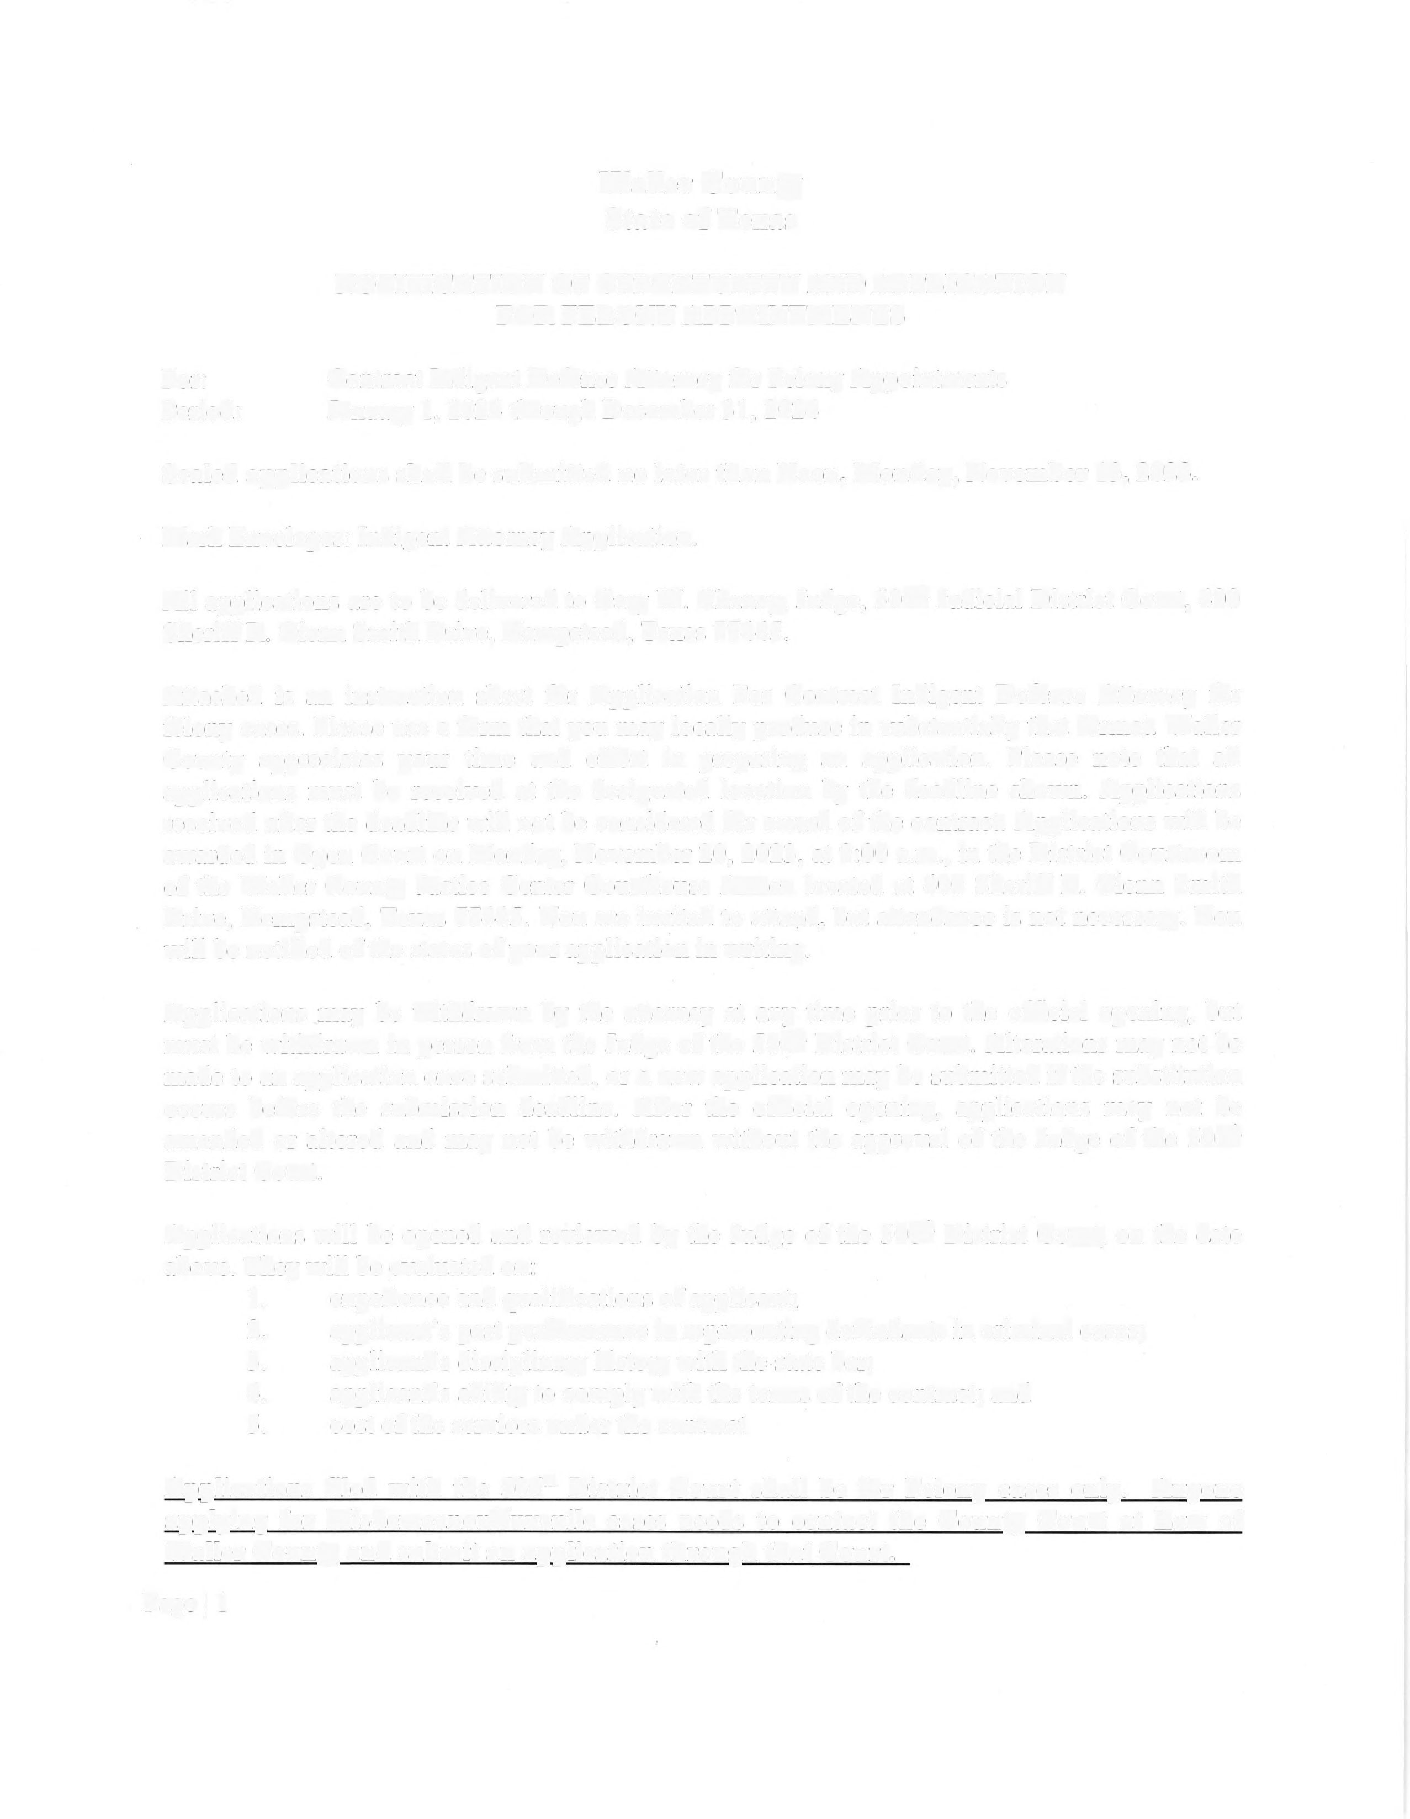

**Sealed applications shall be submitted no later than noon, October 30, 2025.**

All applications are to be addressed and delivered to Elton R. Mathis, Judge of Waller County Court at Law Two (hereinafter “the court”) at 425 FM 1488 Hempstead, Texas 77445 or to his staff.

The misdemeanor (A&B) criminal cases of Waller County are heard by Waller County Court at Law Two, and some lower-level felony cases are also filed in the court pursuant to agreements between the judges of the 506th Judicial District Court and the court. The court was created by the Texas Legislature with both the jurisdiction of a Texas district court and a Texas county court at law. The current criminal caseload of the court is approximately 90% misdemeanor and 10% felony.

Attached is an instruction sheet for Application for Contract Indigent Defense Attorney for criminal cases. Please use a form that you may locally produce in substantially that format. Waller County appreciates your time and effort in preparing an application. Please note that all applications must be received at the designated location by the deadline shown. Applications received after the deadline will not be considered for award of the contract. Applications will be awarded in open court on October 31, 2025 at 9:00 a.m., in the courtroom of the County Court at Law Two at 400 Sheriff R. Glenn Smith Drive, Hempstead, Texas 77445. You are invited to attend, but attendance is not necessary. You will be notified of the status of your application in writing.

Applications may be withdrawn by the attorney at any time prior to the official opening, but must be withdrawn in person from the Judge of Waller County Court at Law Two. Alterations may not be made to an application once submitted. However, a new application may be submitted if the substitution occurs before the submission deadline. After the official opening, applications may not be amended or altered and may not be withdrawn without the approval of the Judge.

Applications will be opened and reviewed by the Judge of the Court, on and after October 30, 2025 at 12:01 p.m. They will be evaluated on:

1. experience and qualifications of applicant;

2. applicant's past performance in representing defendants in criminal cases;

3. applicant's disciplinary history with the state bar;

4. applicant's ability to comply with the terms of the contract; and

5. cost of the services under the contract

6. preferred court assignment of applicant (if the applicant is applying for more than one Waller County Court.)

**Applications filed with Judge Mathis will be for Waller County Court at Law Two primarily handling misdemeanor cases and some lower-level felony cases. There may be occasion when by law/local rules, or by agreement between the judges that some higher-level felony cases are assigned to the court in accordance with its blended misdemeanor/felony jurisdiction.**

Juvenile cases are handled under a separate contract by attorneys that jointly handle CPS and juvenile cases. Those cases are heard primarily in Waller County Court at Law One. Make sure you submit an application to Waller County Court at Law One if you desire to handle CPS/juvenile cases. If applying for any and/or all Waller County Courts you may be selected for only one court per calendar year.

Capital Murder cases, whether or not the death penalty is sought, will not be handled under the contract. Appeals and other post-conviction remedies are not included under the contract. Those cases will be appointed by the trial judges as they arise. Other matters requiring special expertise or extensive forensic training may be assigned outside the contract.

Any misdemeanor cases which MUST by law be heard in a district court will be handled under the contract by attorneys assigned to the 506th Judicial District Court.

Applications shall address the matters listed in the Application instructions, experience and costs of services along with any other relevant information.

Attorneys awarded a contract must have access to an office equipped with modern technology and the Attorney must be willing to work with the District Attorney’s assigned employees on assigned cases. As a condition of contract award, attorneys are expected to make contact with assigned clients within 72 hours of their appointment, either at the jail, in person, or in writing. In addition, attorneys will be required to coordinate office visits with the District Attorney's office to discuss trial preparation and discovery compliance.

Attorneys must meet the minimum attorney qualification requirements of the local indigent defense plan for felony cases, and as set out in the Sample Contract available through the Judge’s office. Thereafter, the attorney must constantly:

Be a member in good standing with the State Bar of Texas;

Professionally perform duties and responsibilities of a licensed attorney for the

State of Texas;

Complete annually such Continuing Legal Education programs as required by the

Texas Judicial Counsel and the Waller County District Court Plan filed with the Texas Indigent Defense Commission for attorneys representing indigent accused persons, which shall include at least 6 hours of Continuing Legal Education in handling criminal cases.

A Sample Contract is available for your review and can be emailed directly to you on request. Please contact the Judge of Waller County Court at Law Two with any questions.

**INSTRUCTIONS FOR APPLICATION**

**FOR CONTRACT REGARDING INDIGENT DEFENSE ATTORNEY FOR CRIMINAL CASES IN WALLER COUNTY, TEXAS**

Please prepare a typed application that contains the information listed below. Applications for Waller County’s criminal cases filed in/transferred to Waller County Court at Law Two (hereinafter “WCC@L2”) are submitted to Judge Elton R. Mathis at 425 FM 1488 Hempstead, Texas 77445. Beginning January 1, 2025 juvenile cases will be handled under a separate contract by attorneys that jointly handle CPS and juvenile cases. Those cases will be heard primarily in Waller County Court at Law #1. Make sure you submit an application to Waller County Court at Law #1 if you desire to handle CPS/juvenile cases. You MAY APPLY FOR MORE THAN ONE WALLER COUNTY COURT. HOWEVER, if applying for any and/or all Waller County Courts you may be selected for only one court per calendar year.

**Applications filed with WCC@L2 shall be for attorneys wanting to primarily handle misdemeanor cases and some low-level felony cases. There may be occasion when by law/local rules or by agreement between the judges that some higher-level felony cases are assigned to WCC@L2 in accordance with its blended misdemeanor/felony jurisdiction.**

The application must contain the following:

Contract Term: January 1, 2026 through December 31, 2026

Name

Business Address Business Phone Cell Phone

Fax Number (If available) Email Address

State Bar Number

Date admitted to Texas Bar

Defense Related Organizations, Clubs, Societies, Associations

Board Certifications, if any, and date awarded

Language proficiency, if any

Name of attorney who will cover for you in an emergency

Sanctions or grievances by the State or Local Bar within the past three years, including those that are pending or unresolved

Complete your application form by using the proper pleadings signature block, and signing above your printed name as an officer of the courts.  **Submit your application no later than noon on October 30, 2025 to Judge Elton R. Mathis at 425 FM 1488 Hempstead, Texas 77445.**

Attach to your application the report of your latest year of Continuing Legal Education on file with the State Bar of Texas

Attach to your application a one-page letter on your business letterhead outlining why you believe you are qualified to serve as a contract indigent defense attorney in the indicated area, as well as other information you believe to be important. AT THE TOP OF YOUR LETTER INDICATE **IN BOLD TYPE** whether you prefer to be assigned to the 506th Judicial District Court or to Waller County Court at Law #2, or to Waller County Court at Law #1 if you are applying for multiple courts.

Place your application packet in a large, sealed envelope labeled with your name and “Application for Indigent Defense Contract”. Deliver the sealed envelope to the Judge of the Waller County Court at Law #2 or his staff before the deadline passes.